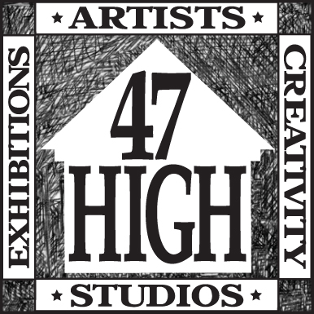

47ARTS
Artist's studios and artist's community.
47 High Street, Philadelphia PA 19144
215-842-2028

APPLICATION FOR ARTIST STUDIO SPACE

Name _____________________________________________________________

Address _____________________________________________________________

_____________________________________________________________

Email _____________________________________________________________

Phone _____________________________________________________________

Cell phone _____________________________________________________________

Emergency contact - Name - relationship
_______________________________________________________________________

Emergency contact - Phone #_______________________________________________

You as an artist: please give us some background about your art and process. Feel free to attach additional sheets.

Your work #1: What do you do and what processes and tools do you use? Please include any power tools, ventilation needs etc. Studio rent includes electric service for standard lights and a radio, a desk fan and a computer only. All other tools or equipment must be approved in writing, before installation.

Your work #2: images - please give us three or more images of your work either prints or digital

References: please provide two references (personal or professional ) with name, contact information, and what your relationship is.

___________________________________________________________________________

___________________________________________________________________________
___________________________________________________________________________
___________________________________________________________________________
___________________________________________________________________________

Current studio prices and availability can be found at
www.47arts.com/studios

Application should be sent to
Questions?
call Elfie at 215-842-2028
or email - info@47arts.com

47arts
47 East High Street
Philadelphia, PA 19144-2116

